Introduction to conceptual modeling

Goal
Understand the basics of conceptual modeling

Background
Conceptual modeling is a catch-all term for all of the ways that people construct representations of challenging problems for a number of reasons:
- to better understand the problem (problem solving)
- to communicate complex ideas to other people (teacher->student)
- to reveal the mental models of complex problems that others have to assess understanding (student->teacher)
A major goal of this course is to master the basics of conceptual modeling in order to better understand CS theory. Conceptual models are already widely used in this area for communicating teacher->student, however, we seldom think about the usefulness of these models to solve problems or to show student learning.

From my personal experience, a conceptual model has two important functions (1) it lifts the user (creator or learner) out of their prior thinking—by activating new parts of the their brain or exposing them to new perspectives and (2) it is used to break down complex concepts into components and their relationships. In some sense, anything can be a conceptual model, but the measure of a good model is how well it represents something in a way that makes the subject appear simpler, while revealing the core dynamics of interest.

Conceptual models can be illustrations or animations, hand- or computer- drawn, or they can be symbols, computer programs, even text. However in this course, we will focus on hand-drawing. Not exclusively, and you are not going to be grading on your skill at drafting. You will be expected to become comfortable at using drawing to understand and explain ideas.

In this exercise, you will learn the basics of conceptual modeling, and to use those basics to better understand diagrams in existing literature. You will then construct your own conceptual models.

The goal of the first part is to gain some background information on what conceptual models are and to refresh your memory on some CS theory basics.

Before class Wednesday, 8/28, please do the following:
- Print out this document and bring it to class. This is to get you into the habit of printing things.
- Read the following wikipedia article on conceptual models. This article is a broad explanation of what a conceptual model is
- Read this article on conceptual modeling in user design. The purpose of this article is to give you a very in-depth sense of how conceptual modeling can be used to solve problems. In this case, it is in the area of UX design.
- Read this page on automata theory.
- The illustrations from the article are shown below. The wikipedia article from step 2. lists a number of different kinds of conceptual models. Identify which type of conceptual model each illustration best represents, and write a paragraph justifying your answer. If none of the types are a good fit, which ones fit the best, the worst. Why?
In class on Wednesday, you will meet with your teammates and discuss your answers, then draft group responses to the questions in (5) that you answered individually (by hand, on one of the paper copies a group member printed out).

On Friday, each group will present to the class and discuss their answers.

To hand this work in, please present a paper copy by Monday with the name of all participating group members on it.

Grading: This project will be graded pass/fail and will constitute about 6% of your final grade.
A.


B.
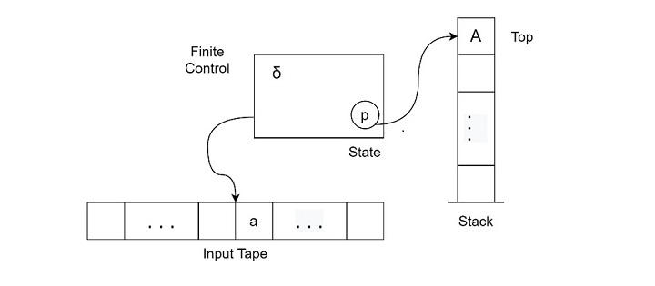

C.
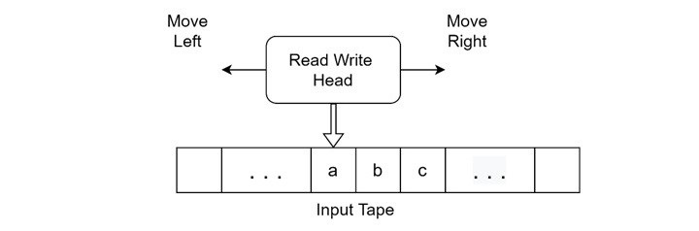

D.
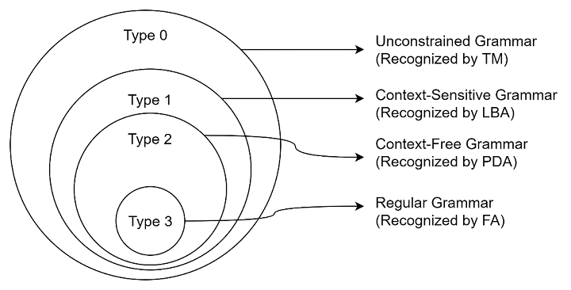



E.
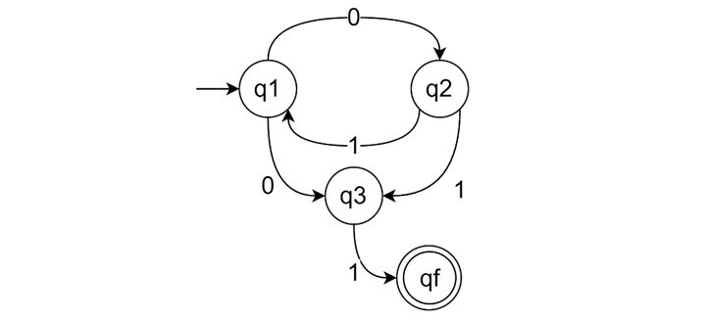

F.
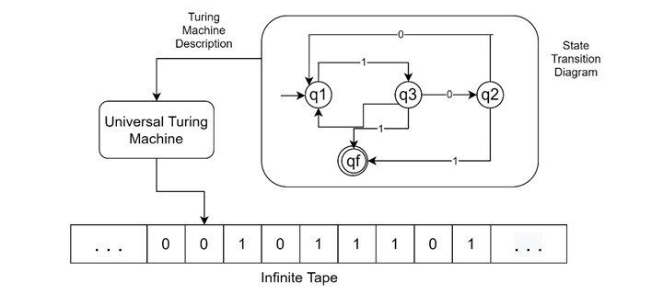

G.
